**Commodity Seasonals Tendencies - My Personal Favorites**

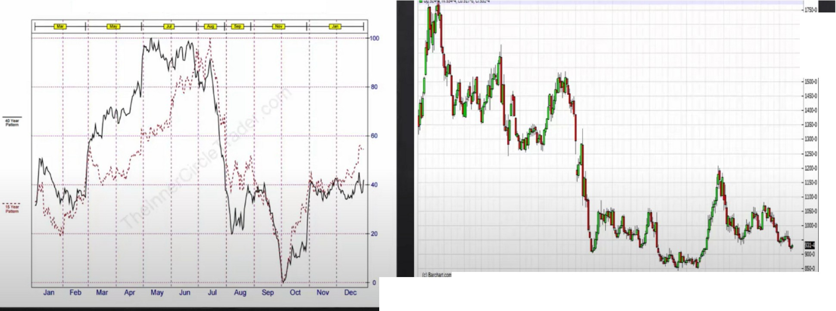

Soybeans(CBOD 40 Year Seasonal(1976-2015)

-u,,.

..,,.

....

_..,.

***JIIU* Ocl lllU /,ff lll O:I la14 *1ft* 111 Ocl mlS *1ft* M Ocl llll6 lff M OCI llllll** ,-IIOO

Seasonal tendencies are not panaceas Its like a roadmap

It gives a expectation of what normally happens during that time of the year

When they dont move in alignemnt thats telling you something as well, theres probably something underlying going on. If were seeing bearishness during february it probably means that theres too much supply

If theres a strong tendency, then the 15 year and 40 year should move in alignment

Longs from february to july,

Shorts from july august to september october

Longs from september going into the follwing summer months

This would be the strongest tendencies if you want to trade commodities

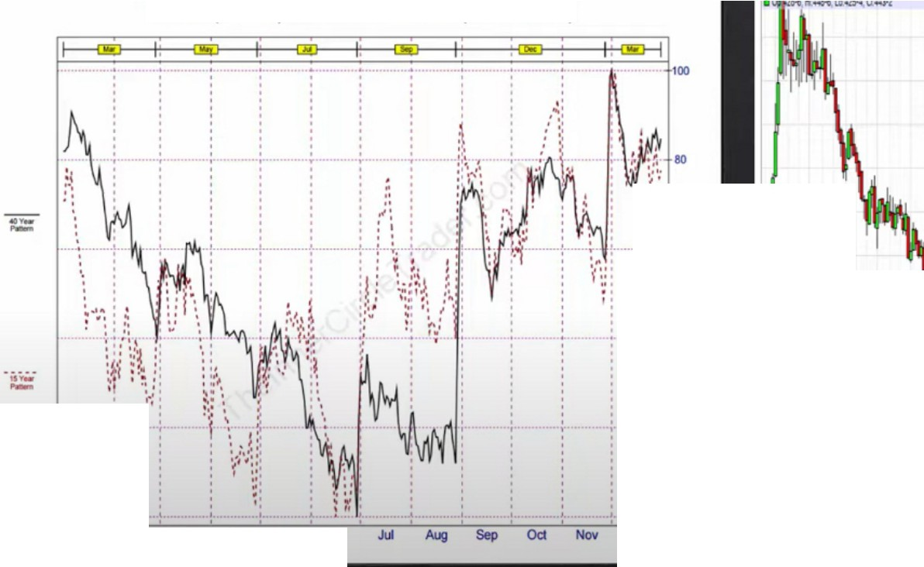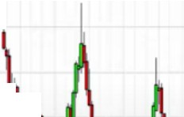

Wheat(CBOD 40 Year Seasonal(1976-2015)

....

....

..

A/\,,

.,,,.

_..,.

....

....

20

**Jan Feb Mar AfK May .kn**

**Dec**

**M.- --·-.-M-OcllaM - -.-M- ---.-.-M- --·-.-**

This one is a bit funky, but can be strong

We can see the weakly is heavily bearish, so best thing to do is focus on bearish seasonal tendencies

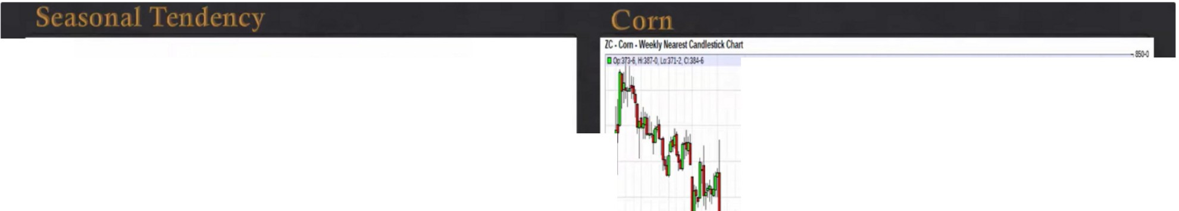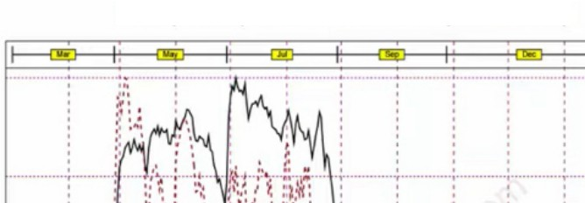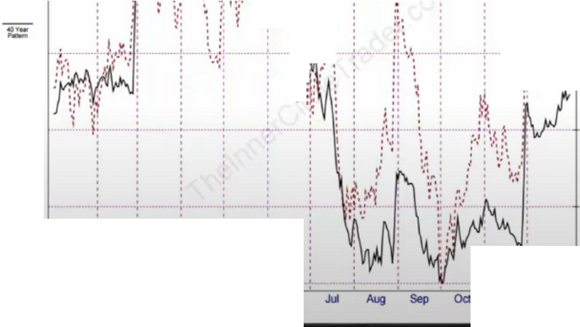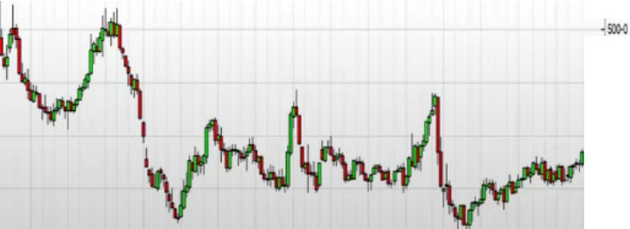

Corn(CBOD 40 Year Seasonal(1976-2015)

·DO

100

....

....

*'{' !* :\

r"

·l;d..

*f*

:::· **00**

f.

...,

....

.•..,

,..

..,,

**Jan Feb Mar AfK May .kn**

_._

**llllU O::I )all l,f, )II Qa Jla1' lif, Jill O::I l1di -'P' )II Qa .,.. *l,fi* lf Ocl )IIU */lfl***

- Doc

*I*

Corn has underlying strength

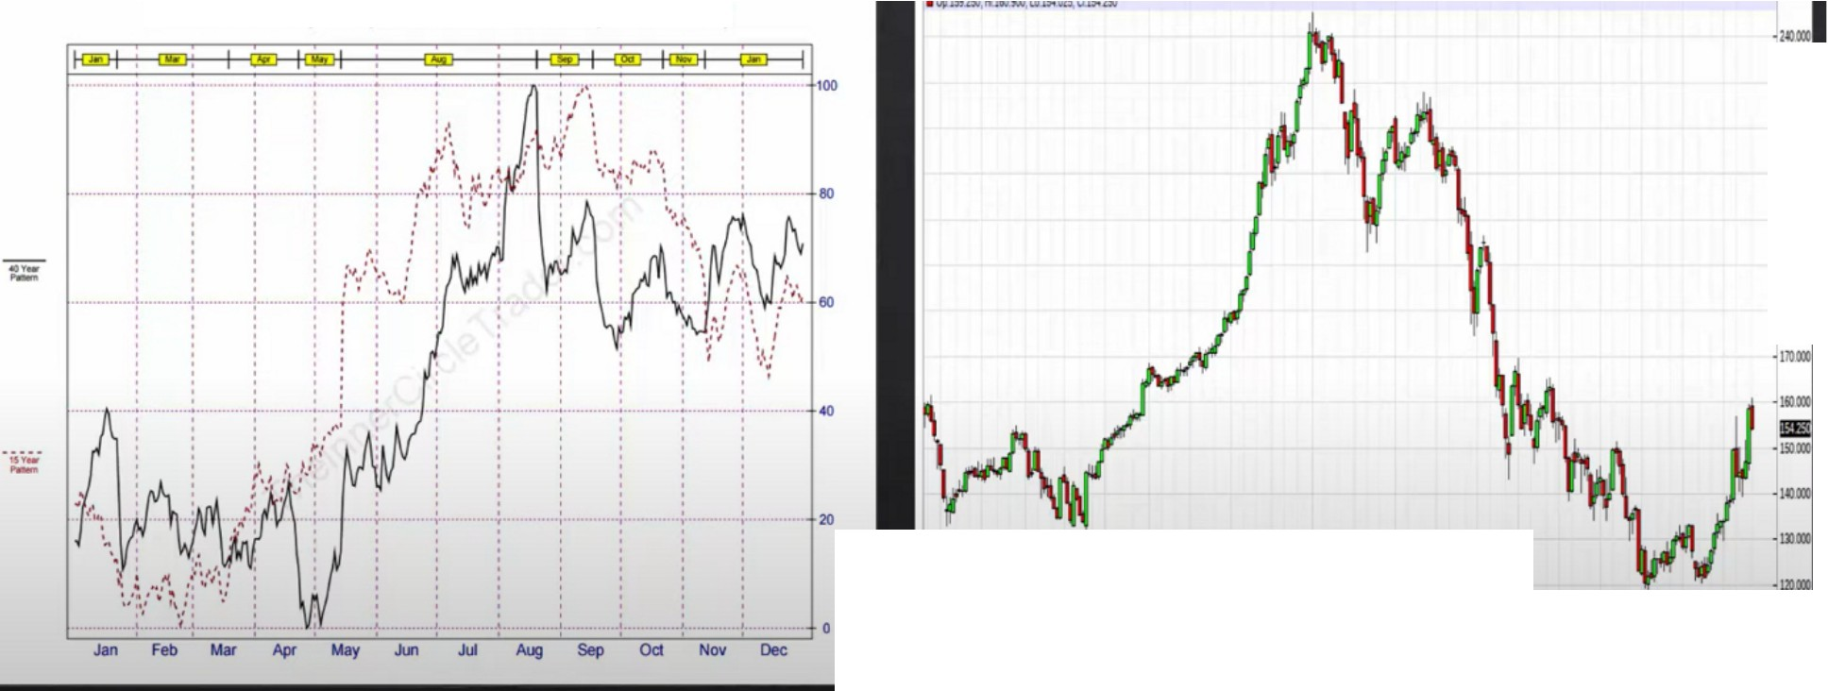

Feeder Cattle(CME) 40 Year Seasonal(1976-2015)

**-mox**

**-2lllOX**

-20,X

**.a,ox**

**-lllOX**

-IIIOX

**.MU oa lllll** ,. ... **oa JaM** ... ... **oa llll!S** ,.. ... **oa** -· • **lll Ila lllU** •

"'

Ive noticed that combining this with institutional orderflow is really strong, if theyre aligned then its really strong. If not then institutional orderflow will likely win.

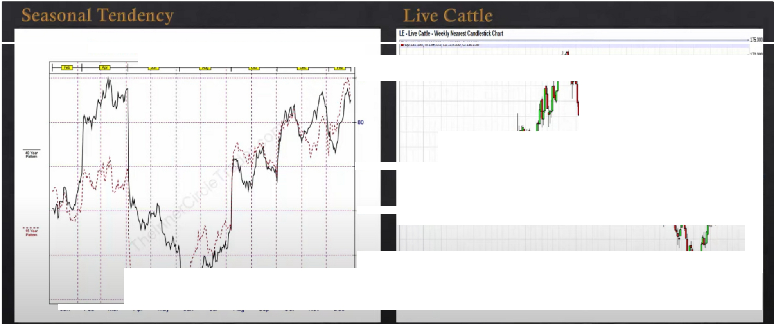

Live Cattle(CME) 40 Year Seasonal(1976-2015)

..

..

\

**·liSOX**

00

**·IIOOX**

**·ISSCIX**

·llOO:

* **16.0X**

**•1'30X**

i.rV

·llSO:

**-!1111**

**-1!,0X**

·"'"

**-usox**

·Ill"

20

·1>0:

.

.

....

Jan

,..

,,, '.

: \)/\N

' '

,...

... ,.

.,

"

...

"'""

..

" '"" "' " "' "

.. ... ..

,..

"'

.. ...

" "'

"

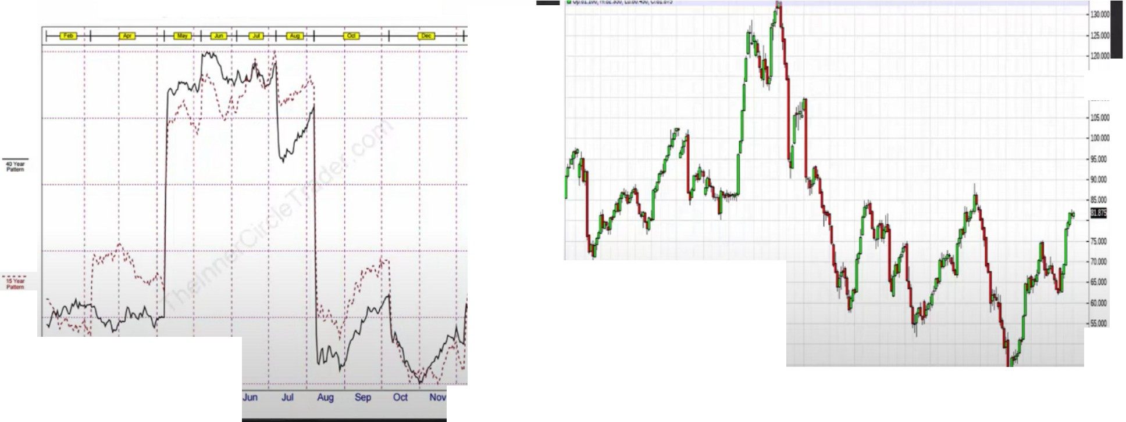

Lean Hogs(CME) 40 Year Seasonal(1976-2015)

..

]""'

'""

... **eo**

..

**JM Feb MIi' Ap May**

**Dec**

-

'**MI**-**J** -**Ga** -**JaD** -**/,f**-**l Jill**

**0a** -**aw**-**Air M** -**0a** -**lllll**-**lS ,._ Jill** -**OU** -**JIi**-**i**■ **• M Ga 11111** ,_

.... "

- "

This one is a goldmine, buy in march april. high forming in may june Moves like these are millionaire makers

This is the best kept secret

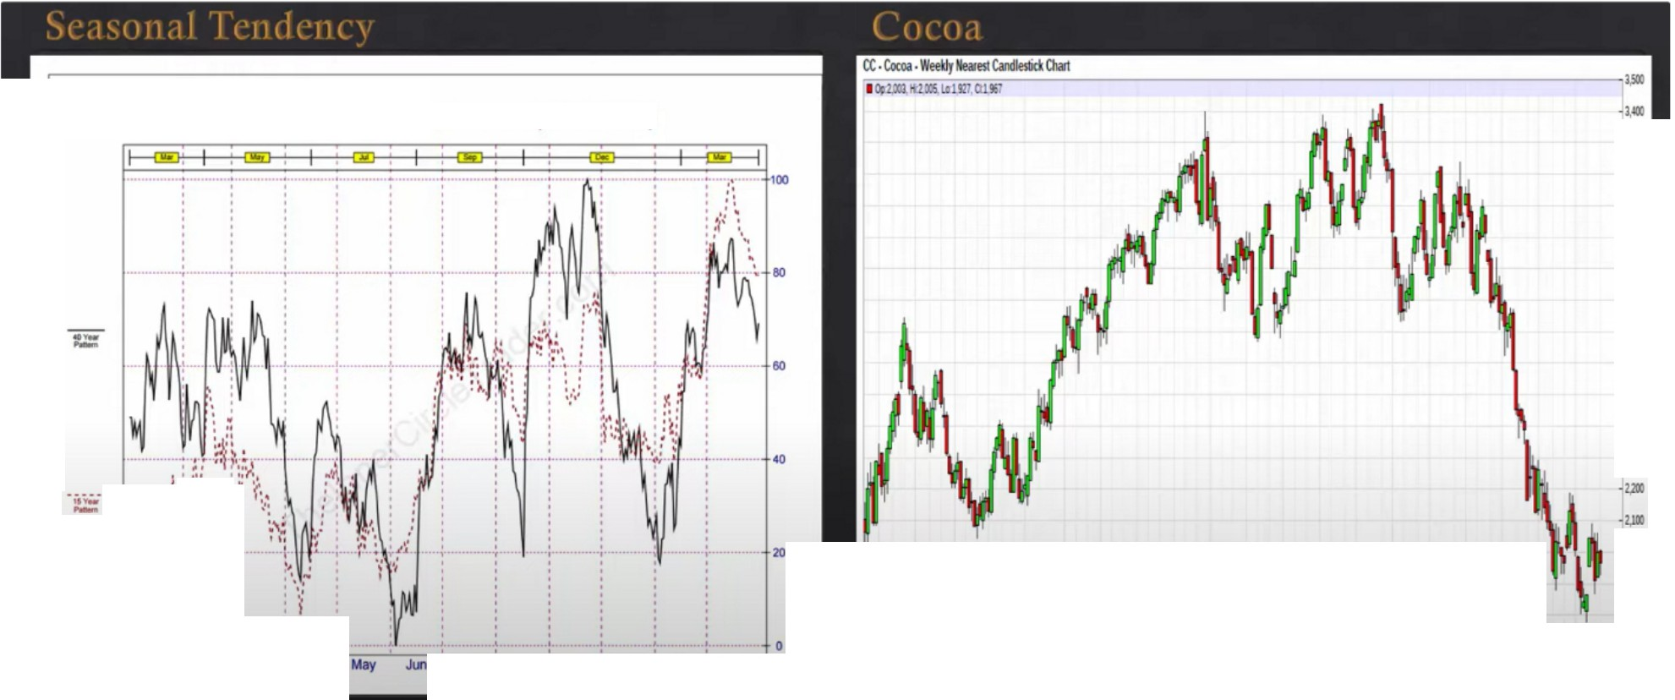

Cocoa(ICE) 40 Year Seasonal(1976-2015)

.,,.

.**·l**,**l**,**JI**.**)**

·J/J!l

....

..,,,

....

.,..

.,...

.,.,.

.,.,.

,tf r-?':

'

j:

**·11**

....

-

**,,. a**

....

**Jan Feb Mar**

**JII Aug Sep 0d**

"" **Dec**

**'111-12 -0a -lllllD-J«--lll -0a -llll-W -Aff -M -oa-al-S -._ -M-G-a -**•• **-**,,,,**-J-ill -0a -llll1-**,_**u,,**

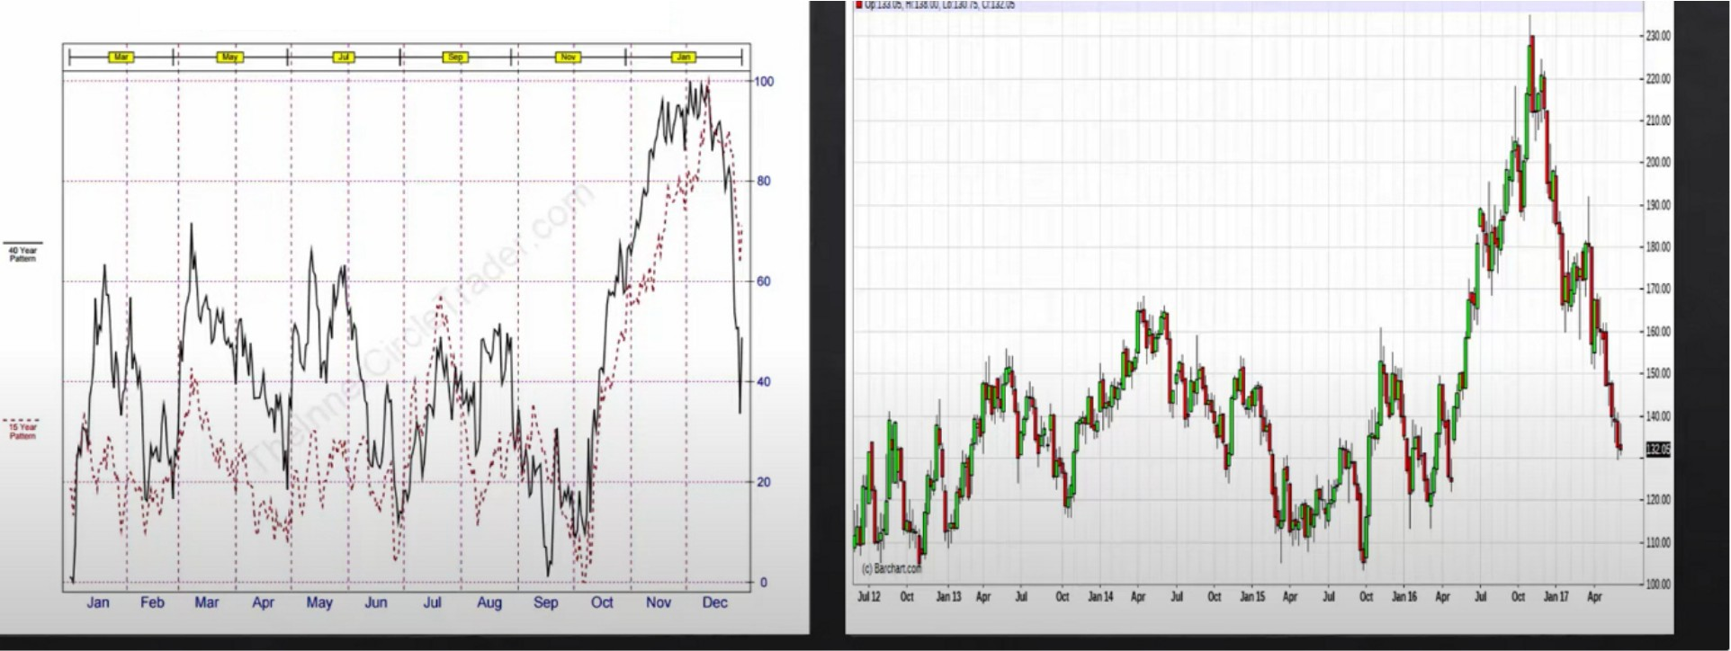

Orange Juice(ICE) 40 Year Seasonal(1976-2015)

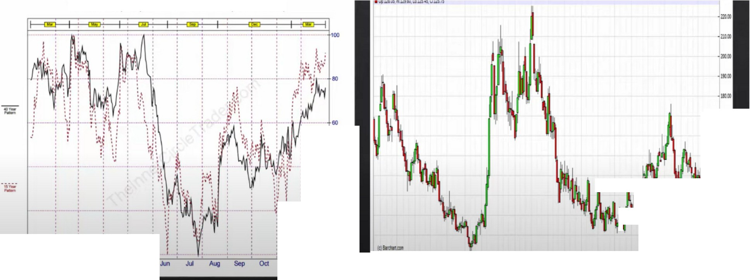

Coffee "C"(ICE) 40 Year Seasonal(1976-2015)

•110111

·160111

.,

·1"•

•! CO

J

I

' ·1"•

- •

I

**Jan Feb Mar**

**May**

**No, Dec**

**JlfU**-**0a**-**•**-**o** -**"-** -**M** -**0a**-**J**-**al&** -**,_** -**llf** -**0a**-**J**-**al!** -**•** -**Jill** -**0a**-•• --,_ -**Jlf** -**0a**-**lll**-**lll** ,-_ •·

When coffee moves it can move a loott

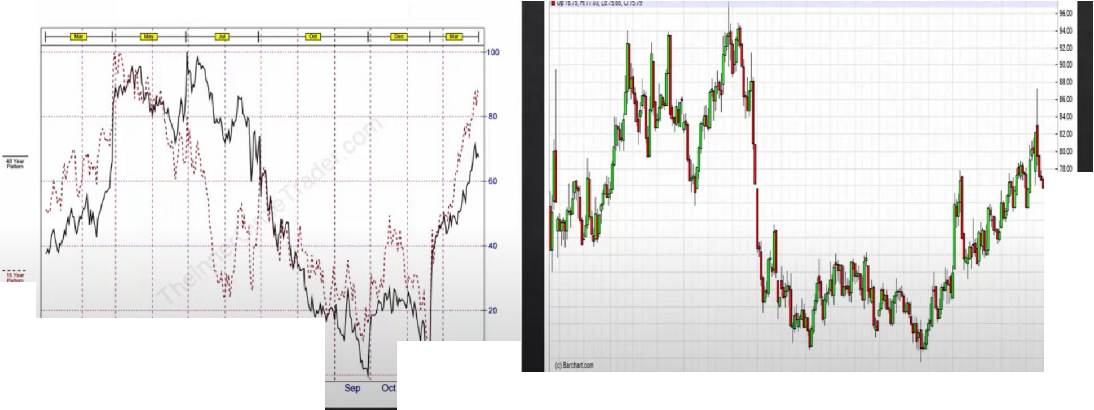

Cotton(ICE) 40 Year Seasonal(1976-2015)

**Jan Feb Mar Apf May Jun Jul A1.J1** ... **Dec llll2 0a Jllllll '- Jlf** -**0a**-**Jl**-**ll1' ,**-**_**

-**1111** -**0a** -**lllllS**-***1ft***-**JIii**-**0**-**a ll**-**lll6** -**,_**

**·11**

•Ml

*-n•*

·••

·••

·••

·••

**·RO**

·••

·••

·••

-**lll** -**0a** -**llllJ**-,_--so

You can see if its not following the normal seasonal tendencies then theres strong underlying strength to go the other way

Financials

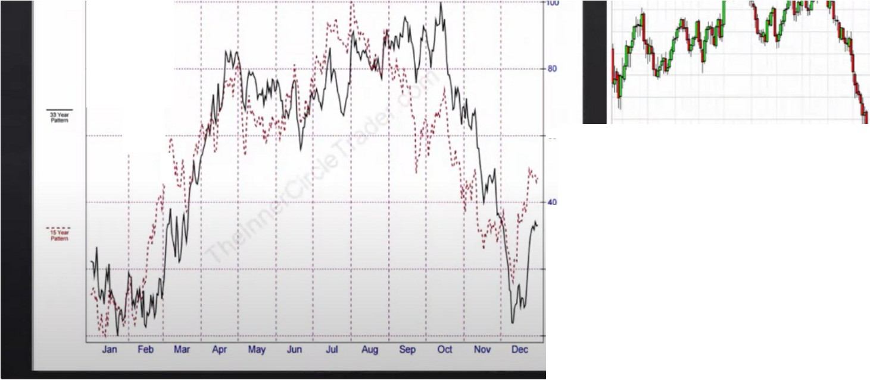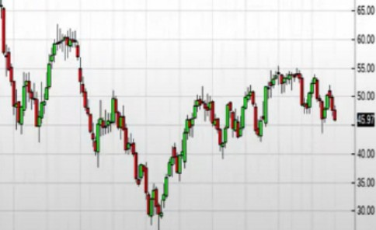

Crude Oil(NYM) 33 Year Seasonal(1983-2015)

...,....

...

···------.-·- --·-.·-

.,

..

,,

::

...

·••

...

20

**MU 0a lllll .--i, 0a .1111' *1ft* Jill 0a llllS • ---;;--i. 0a** -:;-11 - .. -•·

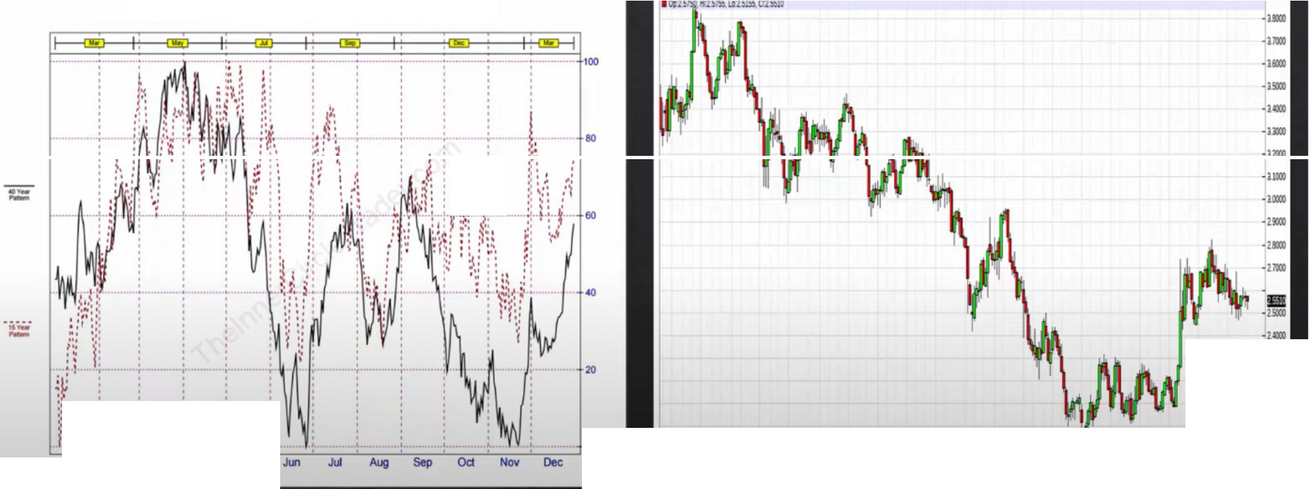

Copper(CMX) 40 Year Seasonal(1976-2015)

*!* j

:_:: ;

·!lllD

....

_,..

**Jan Feb Mat *Apt* May**

-.,_--------------------

_,,.,

**M**-**IJ oa au ,. lii oa llllH *1ft* .w oa a!IS • M oa lllli *1ft* M oa lllU** • -tm

Can move a lot when in a premium, premium will be taught later

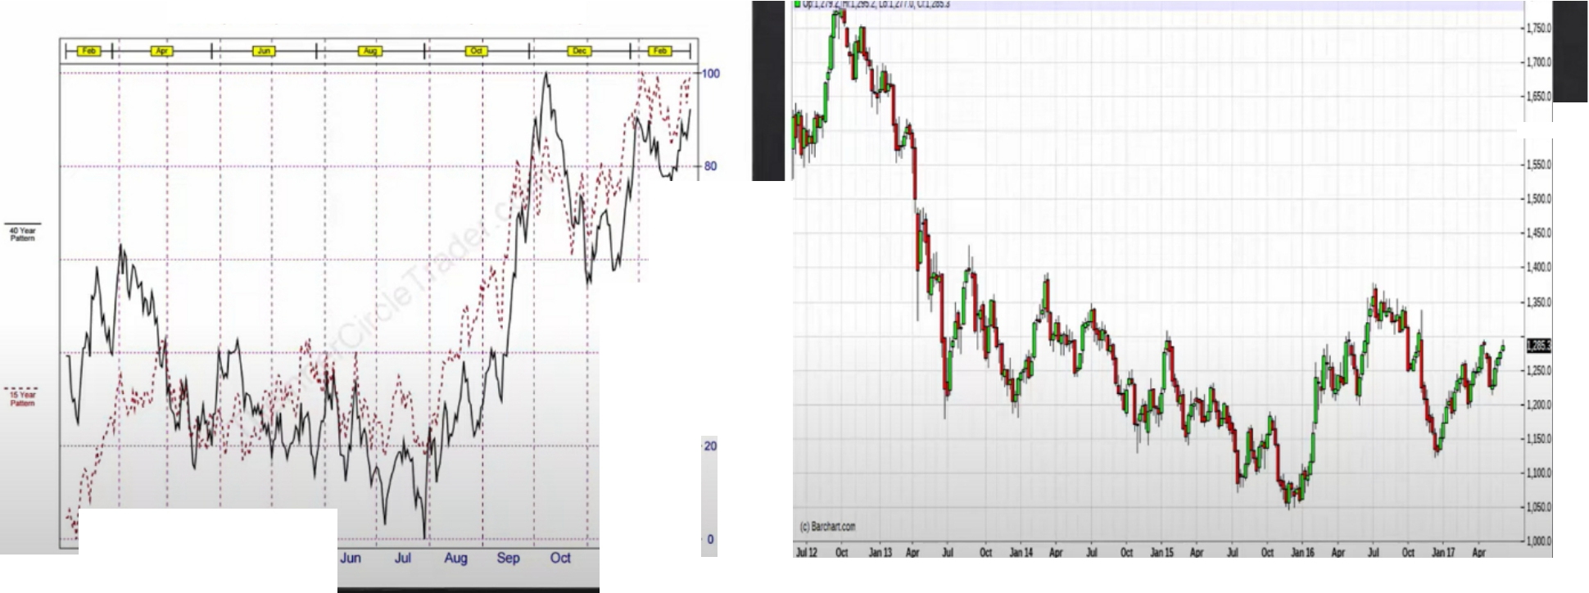

Gold(CMX) 40 Year Seasonal(1976-2015)

·l,lll.C

.,

**Jan Feb Mar *Apt* May**

No,

Dec

Buy your watches in july ,

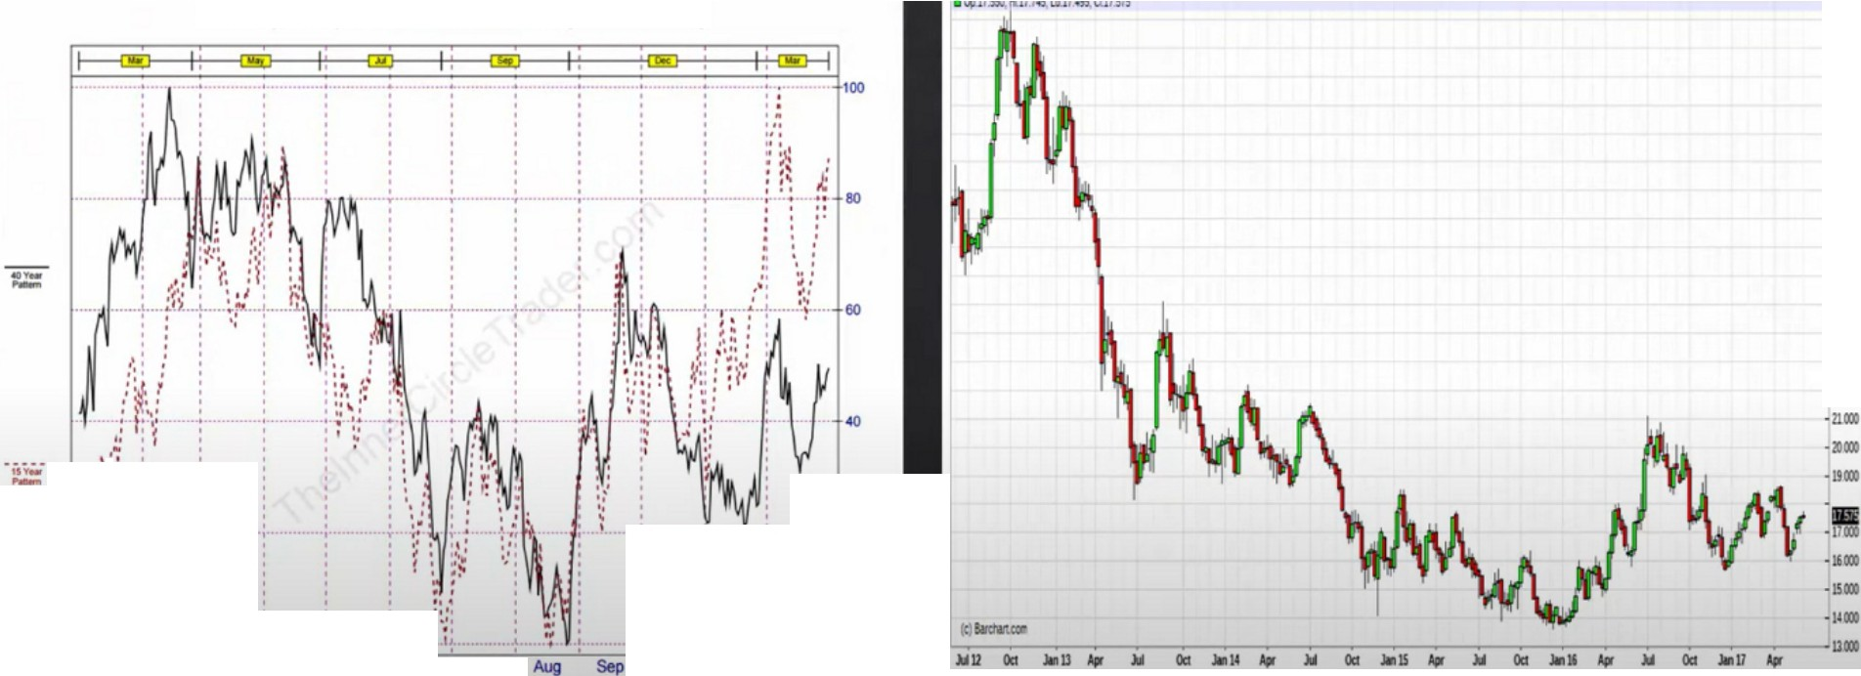

Silver(CMX) 40 Year Seasonal(1976-2015)

....

....

....

....

....

.-.1,.o:.1

....

;t l •

*:;*

**Jan Feb Mar A.pf May Jl.n** Jul

20

Oct Nov Dec

Silver tends to go into a parabolic bull market every 10-12 years Silver here is poised to make a nice run

All the bond markets and currencies seasonal tendencies have been discussed earlier in the mentorship

Blend everything together of what we learned in the mentorship

Make a list every month for the seasonal tendencies, so you get notified each month Then go into the charts and see if theres reasons to justify the seasonal tendency

If its not following the seasonal tendency its telling you something. Either its going into a longer term consolidation or when its going in the opposite direction that means there very siginifcant strength to go to the opposite side and check and see if you can confirm that with the COT hedging program then go to your PD arrays

Study them and theyll surve you well

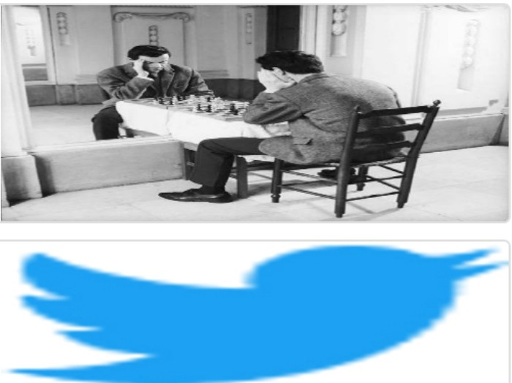Arjo I Twitter, lnstagram I Linktree

Linktree. Make your link do more.

, https://1.co/HhmmTN1fUI

JavaScript is not available.

*"!I* https://twitter.com/arjoio